**BINOMIAL AND POISSON DISTRIBUTION USING EXCEL**

**Assignment Number 4**

Register Number: 1740256

**Date:** 11/12/2017

--------------------------------------------------------------------------------------------

**Aim:**  To compute Binomial probabilities and Poisson probabilities using excel.

**Procedure**:

1. To compute binomial probabilities, we use =binom.dist (x, n, p, cumulative)
2. Cumulative denotes a cumulative distribution function if it is put as true and denotes the probability mass function if it is put as false.
3. For finding Poisson probabilities, the syntax is =Poisson(ʎ, cumulative)

**Question 1**

Consider a binomial experiment of 10 trials with probability ¼. Find the probability of getting

1. No success
2. 2 successes
3. Atmost 2 successes
4. Atleast 2 successes

**Calculations**:

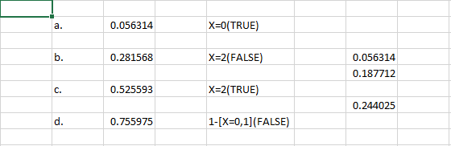

**Conclusions**:

The above calculations show a screenshot of my calculations with the probabilities being computed successfully with each condition in a. b. c. d.

--------------------------------------------------------------------------------------------------------------------------------------

**Aim:**  To compute Binomial probabilities and Poisson probabilities using excel.

**Procedure**:

1. To compute binomial probabilities, we use =binom.dist (x, n, p, cumulative)
2. Cumulative denotes a cumulative distribution function if it is put as true and denotes the probability mass function if it is put as false.
3. For finding Poisson probabilities, the syntax is =Poisson(ʎ, cumulative)

**Question 2**

Calculate the p.m.f of a binomial distribution with n=8 and P = 0.35. Also obtain the cumulative distribution function.

**Calculations**:

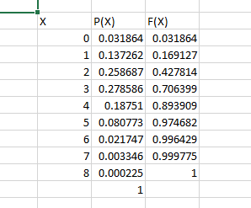

**Conclusions**:

The above calculations show a screenshot of with the probabilities being computed successfully with each condition.

--------------------------------------------------------------------------------------------------------------------------------------